### Java Fundamentals 4-3: Data Types and Operators Practice Activities

### Vocabulary

**1.Named primitive or object storage mechanisms defined in a program. The assigned value may or may not (constants) change**: Variable

**2.Symbols used to do addition, subtraction, multiplication, division, and modular arithmetic in math expressions and formulas**: Arithmetic Operators

**3.The group of Java data types that do not use the keyword new when declared or initialized. Primitive Data Types store the value in the same place in memory as the variable name**: Primitive Data Types

**4.The smallest Java primitive type (1 byte) that can hold an integer value**: byte

**5.This data type (8 bytes) is the largest integer type**: long

**6.The formatting and naming standards that most programmers follow**: Coding Conventions

**7.This Java primitive data type (4 bytes) can hold integer values**: int

**8.This Java primitive data type (8 bytes) is the largest primitive that can hold a decimal value**: double

**9.When a variable is assigned a value for the first time**: Initialization

**10.This Java primitive data type (4 bytes) can be initialized with a decimal number preceding letter f. Example: float x = 3.5f**: float

**11.Can be any number, text, or other information that represents a value; used to initialize a primitive type**: Literal

**12.A Java statement when a variable is defined but not necessarily assigned a value. Example: int x**: Declaration

**13.This word describes the mathematical precedence that a variable has in a Java program**: Scope

**14.A Java primitive data type (2 bytes) that can hold single character values. Example: 'a', '#', or 'X'**: char

**15.Used to describe the block of code where a variable exists in a program. A block of code is denoted by {}**: Scope

**16.The process of explicitly modifying one data type to become a different data type**: Casting

**17.A concept where a number is always rounded down to the nearest integer**: Truncation

**18.The equals sign** = **used in a Java statement to assign a value to a variable**: Assignment Operator

**19.The process of modifying one data type to become a different data type, this may be implicit or explicit**: Type Conversion

**20.A Java primitive data type (2 bytes) that holds integer numbers within a shorter range than an int**: short

**21..A one-bit Java primitive type that can hold the value true or false**: boolean

### Try It/Solve It

#### Triangle Area Calculation Program

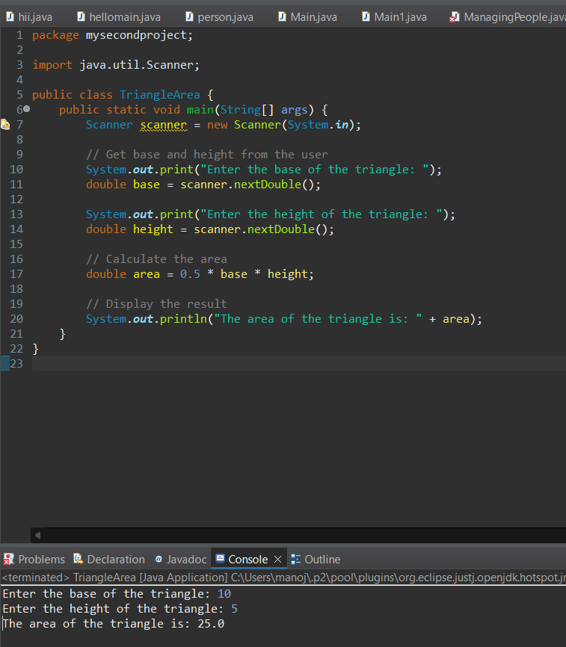

#### 2. Math Formulas

a. a=x5−64a = \sqrt{\frac{x^5 - 6}{4}}a=4x5−6​​

double a = Math.sqrt((Math.pow(x, 5) - 6) / 4);

b. b=xy−6xb = xy - 6xb=xy−6x

double b = x * y - 6 * x;

c. c=4⋅cos⁡(z5)−sin⁡(x2)c = 4 \cdot \cos\left(\frac{z}{5}\right) - \sin(x^2)c=4⋅cos(5z​)−sin(x2)

double c = 4 * Math.cos(z / 5) - Math.sin(Math.pow(x, 2));

d. d=x4−6x−y3d = x^4 - \sqrt{6x - y^3}d=x4−6x−y3​

double d = Math.pow(x, 4) - Math.sqrt(6 * x - Math.pow(y, 3));

e. e=1y−1x−2ye = \frac{1}{y} - \frac{1}{x - 2y}e=y1​−x−2y1​

double e = 1.0 / y - 1.0 / (x - 2 * y);

f. f=7⋅cos⁡(5−sin⁡(3x−4))f = 7 \cdot \cos(\sqrt{5} - \sin(\sqrt{3x} - 4))f=7⋅cos(5​−sin(3x​−4))

double f = 7 * Math.cos(Math.sqrt(5) - Math.sin(Math.sqrt(3 * x) - 4));

#### 3. Field Trip Bus Calculation

### 

### Boolean expressions

int i = 5;

int j = 6;

boolean true_false;

true_false = (j < 5); // false

true_false = (j > 3); // true

true_false = (j < i); // false

true_false = (i < 5); // false

true_false = (j <= 5); // false

true_false = (6 < 6); // false

true_false = (i != j); // true

true_false = (i == j || i < 50); // true

true_false = (i == j && i < 50); // false

true_false = (i > j || true_false && j >= 4); // true

true_false = (!(i < 2 && j == 5)); // true

true_false = !true_false; // false

#### 5. Explanation of Incorrect Declarations

int 2beOrNot2be;

* + Variable names cannot start with a digit.

float price index;

* + Variable names cannot contain spaces.

double lastYear'sPrice;

* + Variable names cannot contain apostrophes.

long class;

* + class is a reserved keyword in Java.

#### 6. Explanation of Variable Naming Conventions

int cadence=3, speed=55, gear=4;

* + It is a good practice to declare each variable on a new line for readability.

final double SALES_TAX = .06;

* + Constants should be in all uppercase letters with words separated by underscores.

double gearRatio = .5;

* + This follows the naming convention.

int currentGear = 5;

* + This follows the naming convention.

int c = 3, s = 55, g = 4;

* + Single-letter variable names should be avoided except in specific contexts like loop counters.

final double salesTax = .06;

* + Constants should be in all uppercase letters with words separated by underscores.

double gearratio = .05, Gear = 4;

* + Variable names should follow camel case. Gear does not follow naming conventions for variables.

int current_gear;

* + Underscores are generally avoided in variable names in favor of camel case.

boolean gameOver = false;

* + This follows the naming convention.

int students = 50, classes = 3;

* + It is a good practice to declare each variable on a new line for readability.

double sales_tax;

* + Underscores are generally avoided in variable names in favor of camel case.

short number1;

* + This follows the naming convention.